RAMDEOBABA UNIVERSITY NAGPUR



Assignment-1
Session: 2025-26
M.C.A. (AIML) Semester-II
DBMS

Name: Rishika Soni
Batch: A3
Roll Number: 48

Aim – Implementation of DDL commands of SQL with suitable examples
a) Create table b) Alter table c) Truncate table d) Drop table
Implementation of DML commands of SQL with suitable examples
a) Select b) Insert c) Update d) Delete

Theory:
SQL (Structured Query Language) is a standard language used to communicate with a database. It allows users to create database structures, store data, modify data, and retrieve information efficiently.
SQL commands are broadly classified into two categories:
- DDL (Data Definition Language)
- DML (Data Manipulation Language)

1. DDL (Data Definition Language)
DDL commands are used to define, modify, or remove the structure of database objects such as tables. These commands affect the schema of the database.

a) CREATE TABLE
Definition:
The CREATE TABLE command is used to create a new table in the database with specified columns and data types.
Purpose:
- Defines the structure of a table
- Specifies column names and data types
- Creates an empty table
Example:
A table named STUDENT is created with columns for Roll Number, Name, and Age.
Key Points:
- A table is created only once
- No data is inserted during creation
- The structure can be modified later using ALTER

b) ALTER TABLE
Definition:
The ALTER TABLE command is used to modify the structure of an existing table.
Purpose:
- Add a new column
- Modify an existing column
- Delete a column
Example:
A new column EMAIL is added to the STUDENT table.
Key Points:
- Existing data is preserved
- Used when table design needs changes
- Works only on existing tables

c) TRUNCATE TABLE
Definition:
The TRUNCATE TABLE command is used to remove all records from a table permanently while keeping the table structure intact.
Purpose:
- Delete all rows quickly
- Free storage space
Example:
All records from the STUDENT table are removed, but the table still exists.
Key Points:
- Faster than DELETE
- Cannot be rolled back
- Table structure remains unchanged

d) DROP TABLE
Definition:
The DROP TABLE command is used to delete a table completely from the database.
Purpose:
- Remove a table and its data permanently
Example:
The STUDENT table is deleted from the database.
Key Points:
- Both structure and data are removed
- Cannot be recovered
- Should be used carefully

2. DML (Data Manipulation Language)
DML commands are used to manipulate data stored in tables. These commands do not change the structure of the table.

a) SELECT
Definition:
The SELECT command is used to retrieve data from one or more tables.
Purpose:
- View records
- Fetch specific columns or rows
Example:
All student records are displayed from the STUDENT table.
Key Points:
- Does not modify data
- Most frequently used SQL command
- Can be used with conditions

b) INSERT
Definition:
The INSERT command is used to add new records into a table.
Purpose:
- Store new data in the database
Example:
A new student record is added to the STUDENT table.
Key Points:
- Adds data row by row
- Values must match column data types
- Cannot insert data without a table

c) UPDATE
Definition:
The UPDATE command is used to modify existing records in a table.
Purpose:
- Change one or more values in existing rows
Example:
The age of a student is updated in the STUDENT table.
Key Points:
- Affects existing records only
- Can update one or multiple rows
- Conditions should be used carefully

d) DELETE
Definition:
The DELETE command is used to remove specific records from a table.
Purpose:
- Delete unwanted data
Example:
A student record with a specific roll number is removed.
Key Points:
- Table structure remains intact
- Can be rolled back
- Works row by row
Difference Between DDL and DML
DDL | DML
Deals with table structure | Deals with table data
CREATE, ALTER, DROP | SELECT, INSERT, UPDATE, DELETE
Auto-commit | Can be rolled back
Affects schema | Affects records

Implementation:

create table DEPOSIT (
Actno Number(30),
Cname Varchar(30),
Bname Varchar(30),
Amount Number(8,2),
Adate Date

);

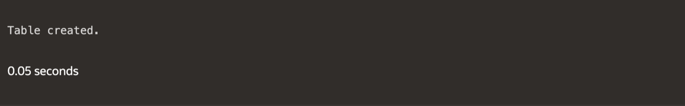

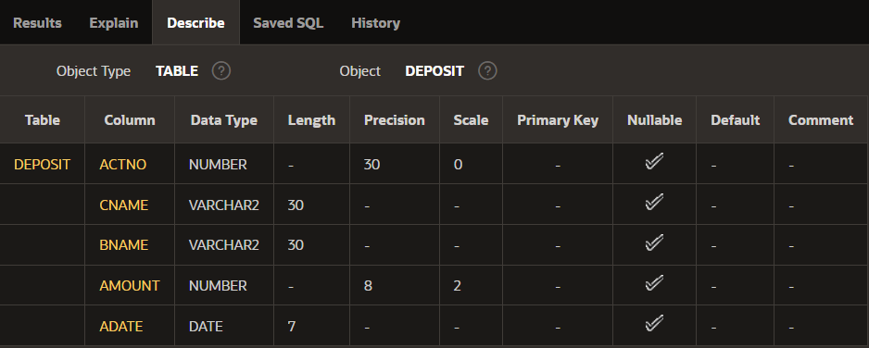

create table BRANCH(
Bname varchar(30),
City varchar(30)

);



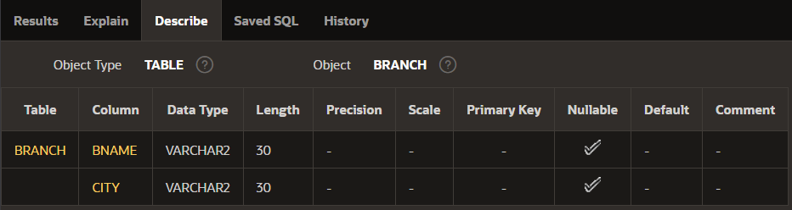
create table CUSTOMERS (
Cname varchar(30),
City varchar(30)
);



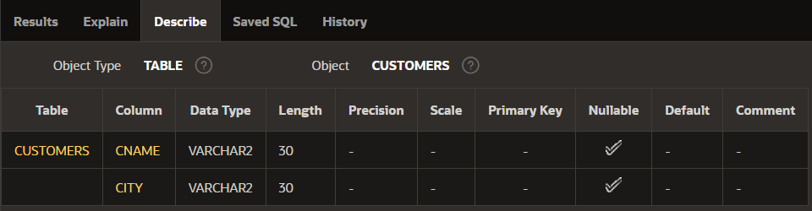

create table BORROW (
Loanno Number(30),
Cname Varchar(30),
Bname Varchar(30),
Amount Number(8,2)
);



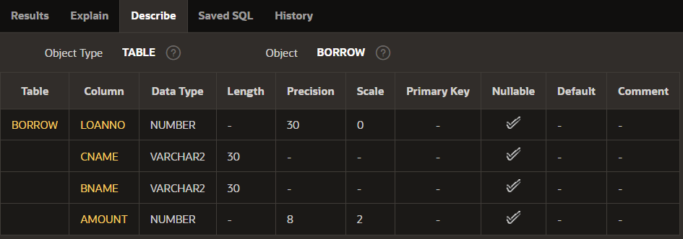

1. Add new column DOB into the CUSTOMER table.
Alter table CUSTOMERS add DOB DATE;
DESC CUSTOMERS;

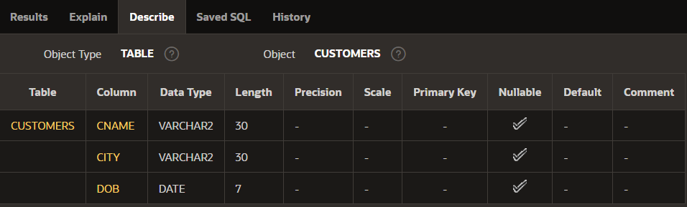

2. Add LOCATION column in BRANCH table
Alter table BRANCH add LOCATION Varchar(30);
DESC BRANCH;

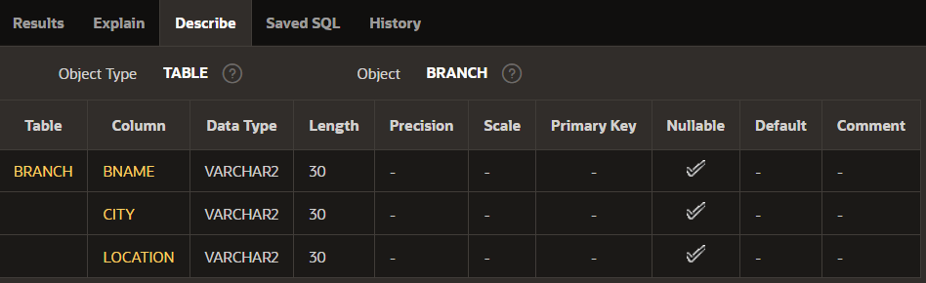

3. Modify customer name space to 35 characters.
Alter table CUSTOMERS Modify Cname Varchar(35);
DESC CUSTOMERS;

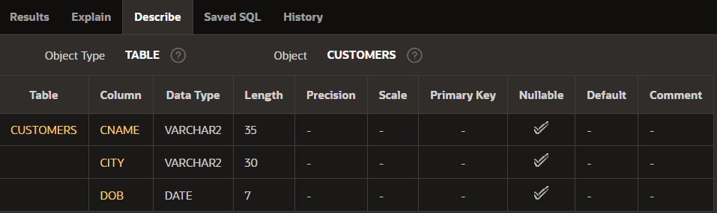

4. Change datatype of Loan number column to numeric type.
Alter table BORROW Modify Loanno Number(20);
DESC BORROW;

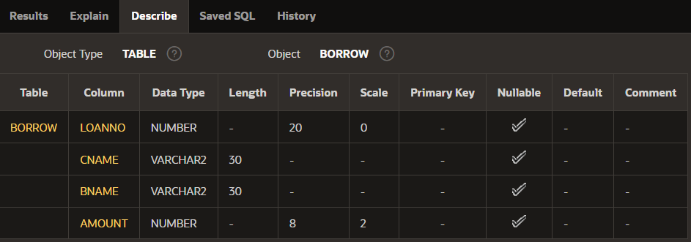

5. Delete LOCATION column
ALTER TABLE BRANCH DROP COLUMN LOCATION;

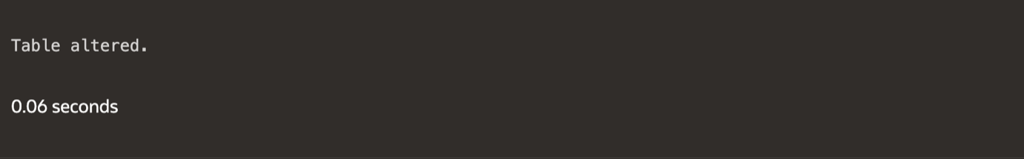

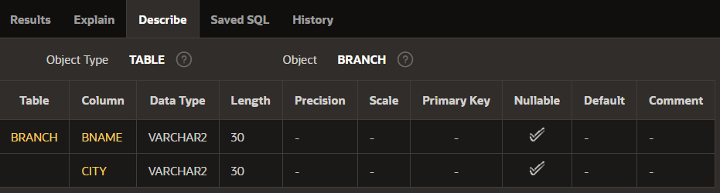

6. Create DEPOSIT_TMP table that contains all information of DEPOSIT table
CREATE TABLE DEPOSIT_TMP AS SELECT * FROM DEPOSIT;
DESC DEPOSIT_TMP;



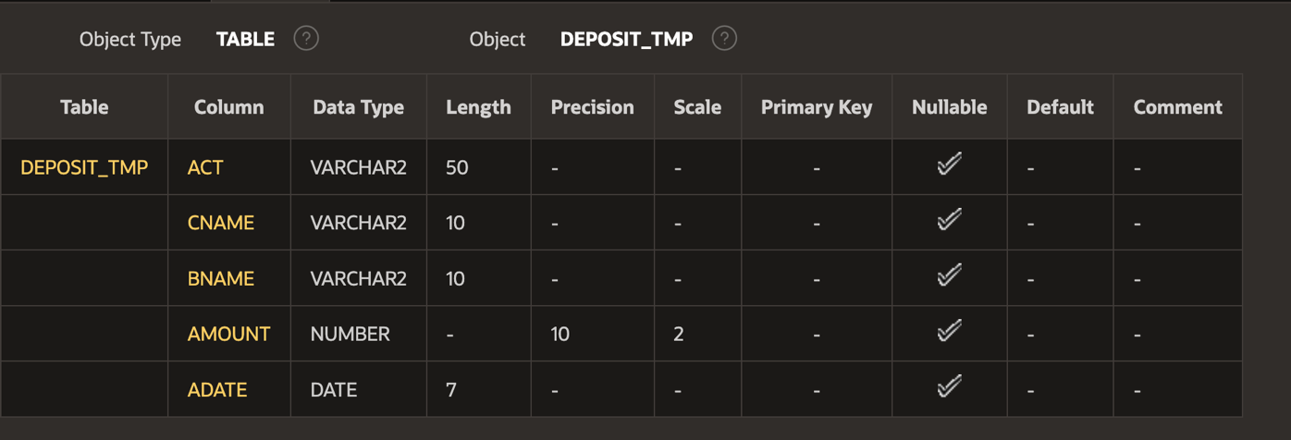
7. Create BRANCH_TMP table that contains only structure same as BRANCH table.
CREATE TABLE BRANCH_TMP AS SELECT * FROM BRANCH WHERE 1=0;
DESC BRANCH_TMP;

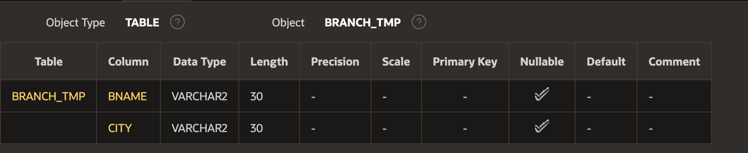

8. Remove all rows from DEPOSIT_TMP table.
TRUNCATE TABLE DEPOSIT_TMP;
DESC DEPOSIT_TMP;

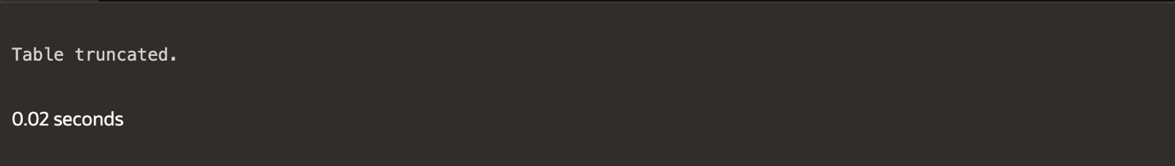

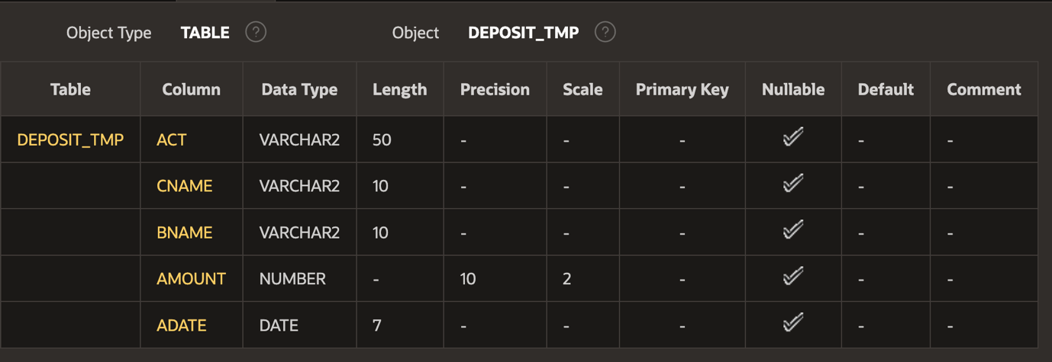

9. Delete DEPOSIT_TMP.
DROP TABLE DEPOSIT_TMP;
DESC DEPOSIT_TMP;

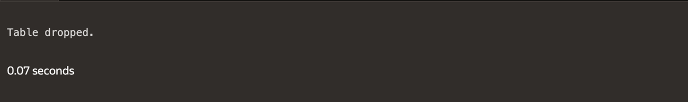

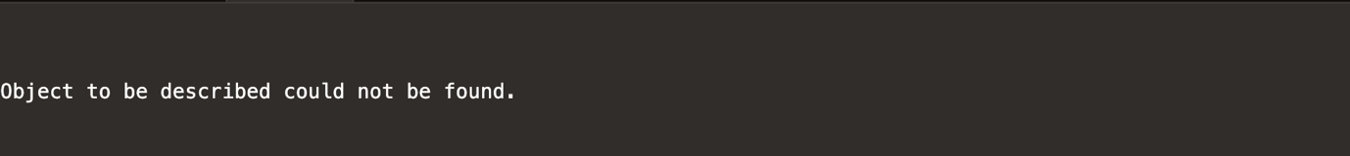

ii) Insert the data as shown below.

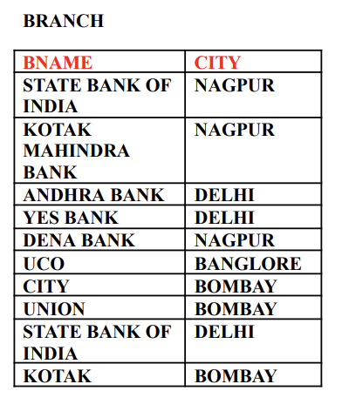
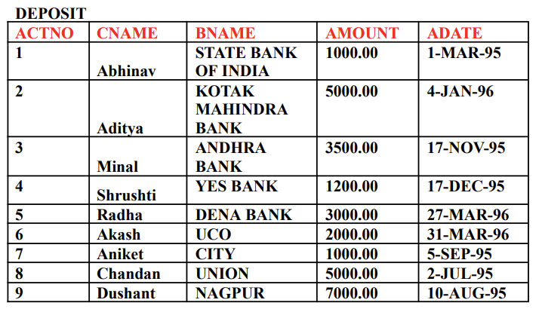

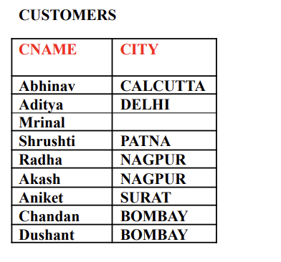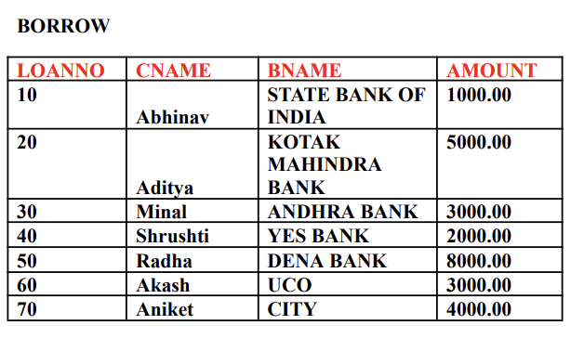

-- DEPOSIT
INSERT INTO DEPOSIT VALUES
(1, 'Abhinav', 'STATE BANK OF INDIA', 1000.00, TO_DATE('01-MAR-1995','DD-MON-YYYY'));
INSERT INTO DEPOSIT VALUES
(2, 'Aditya', 'KOTAK MAHINDRA BANK', 5000.00, TO_DATE('04-JAN-1996','DD-MON-YYYY'));
INSERT INTO DEPOSIT VALUES
(3, 'Minal', 'ANDHRA BANK', 3500.00, TO_DATE('17-NOV-1995','DD-MON-YYYY'));
INSERT INTO DEPOSIT VALUES
(4, 'Shrushti', 'YES BANK', 1200.00, TO_DATE('17-DEC-1995','DD-MON-YYYY'));
INSERT INTO DEPOSIT VALUES
(5, 'Radha', 'DENA BANK', 3000.00, TO_DATE('27-MAR-1996','DD-MON-YYYY'));
INSERT INTO DEPOSIT VALUES
(6, 'Akash', 'UCO', 2000.00, TO_DATE('31-MAR-1996','DD-MON-YYYY'));
INSERT INTO DEPOSIT VALUES
(7, 'Aniket', 'CITY', 1000.00, TO_DATE('05-SEP-1995','DD-MON-YYYY'));
INSERT INTO DEPOSIT VALUES
(8, 'Chandan', 'UNION', 5000.00, TO_DATE('02-JUL-1995','DD-MON-YYYY'));
INSERT INTO DEPOSIT VALUES
(9, 'Dushant', 'NAGPUR', 7000.00, TO_DATE('10-AUG-1995','DD-MON-YYYY'));

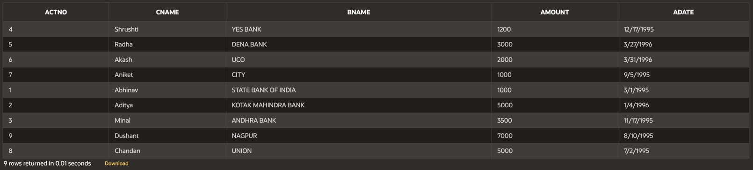

-- BRANCH
INSERT INTO BRANCH VALUES ('STATE BANK OF INDIA', 'NAGPUR');
INSERT INTO BRANCH VALUES ('KOTAK MAHINDRA BANK', 'NAGPUR');
INSERT INTO BRANCH VALUES ('ANDHRA BANK', 'DELHI');
INSERT INTO BRANCH VALUES ('YES BANK', 'DELHI');
INSERT INTO BRANCH VALUES ('DENA BANK', 'NAGPUR');
INSERT INTO BRANCH VALUES ('UCO', 'BANGLORE');
INSERT INTO BRANCH VALUES ('CITY', 'BOMBAY');
INSERT INTO BRANCH VALUES ('UNION', 'BOMBAY');
INSERT INTO BRANCH VALUES ('STATE BANK OF INDIA', 'DELHI');
INSERT INTO BRANCH VALUES ('KOTAK MAHINDRA BANK', 'BOMBAY');

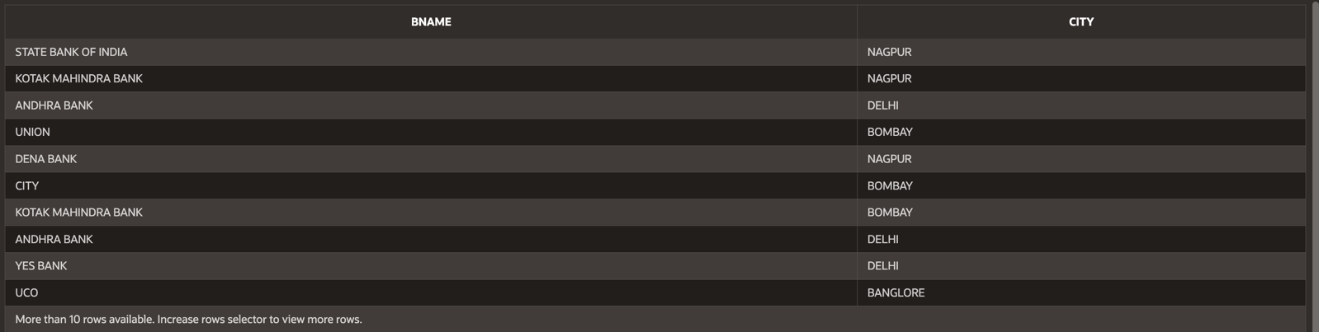

-- CUSTOMERS
INSERT INTO CUSTOMERS VALUES ('Abhinav', 'CALCUTTA');
INSERT INTO CUSTOMERS VALUES ('Aditya', 'DELHI');
INSERT INTO CUSTOMERS VALUES ('Mrinal', 'DELHI');
INSERT INTO CUSTOMERS VALUES ('Shrushti', 'PATNA');
INSERT INTO CUSTOMERS VALUES ('Radha', 'NAGPUR');
INSERT INTO CUSTOMERS VALUES ('Akash', 'NAGPUR');
INSERT INTO CUSTOMERS VALUES ('Aniket', 'SURAT');
INSERT INTO CUSTOMERS VALUES ('Chandan', 'BOMBAY');
INSERT INTO CUSTOMERS VALUES ('Dushant', 'BOMBAY');

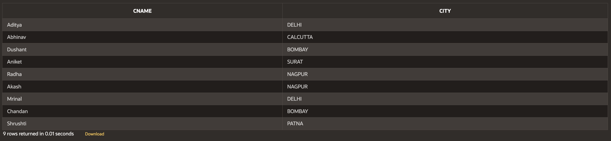

-- BORROW
INSERT INTO BORROW VALUES (10, 'Abhinav', 'STATE BANK OF INDIA', 1000.00);
INSERT INTO BORROW VALUES (20, 'Aditya', 'KOTAK MAHINDRA BANK', 5000.00);
INSERT INTO BORROW VALUES (30, 'Minal', 'ANDHRA BANK', 3000.00);
INSERT INTO BORROW VALUES (40, 'Shrushti', 'YES BANK', 2000.00);
INSERT INTO BORROW VALUES (50, 'Radha', 'DENA BANK', 8000.00);
INSERT INTO BORROW VALUES (60, 'Akash', 'UCO', 3000.00);
INSERT INTO BORROW VALUES (70, 'Aniket', 'CITY', 4000.00);

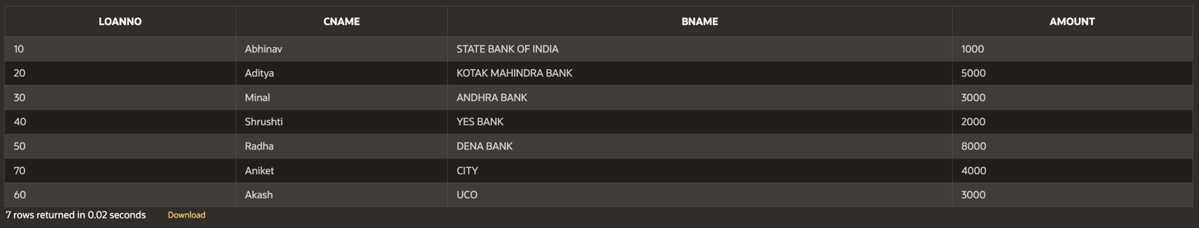

iii) From the above given tables perform the following queries:

(1) Describe deposit, branch.

DESC DEPOSIT;
DESC BRANCH;

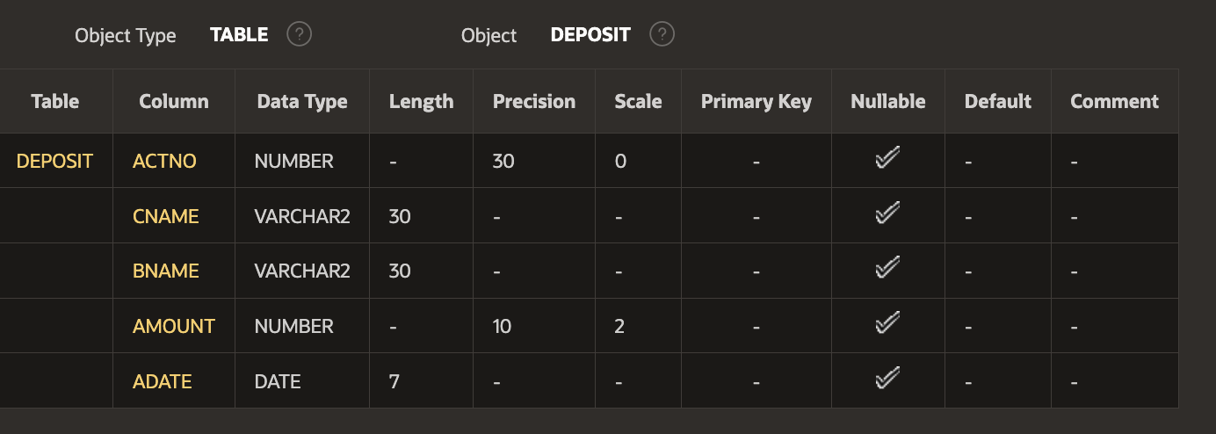

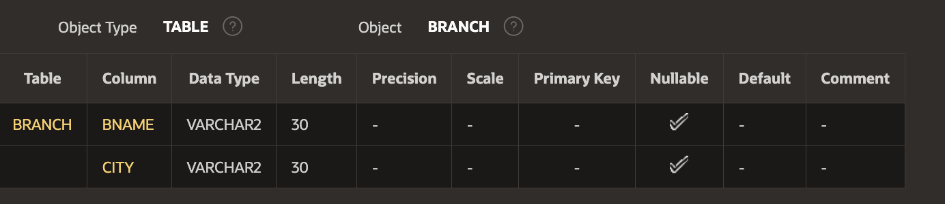

(2) Describe borrow, customers.

DESC BORROW;
DESC CUSTOMERS;

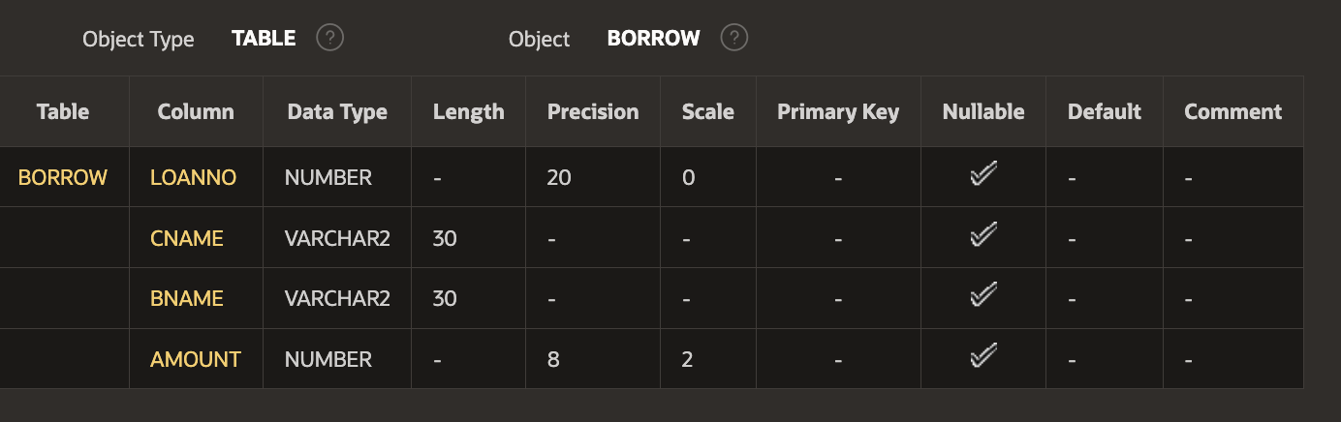

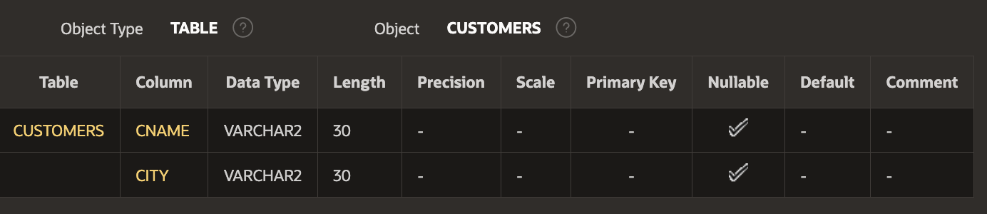

(3) List all data from table DEPOSIT.

SELECT * FROM DEPOSIT;



(4) Give account no and amount of depositors.

SELECT ACTNO, AMOUNT FROM DEPOSIT;

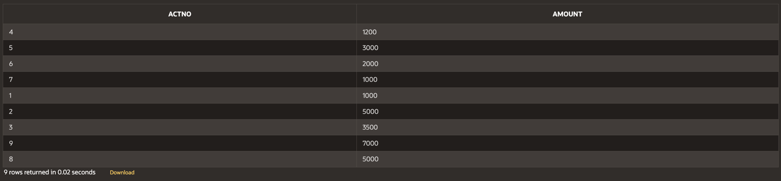

(5) Give name of depositors having amount greater than 4000.

SELECT CNAME , BNAME FROM DEPOSIT WHERE AMOUNT > 4000;

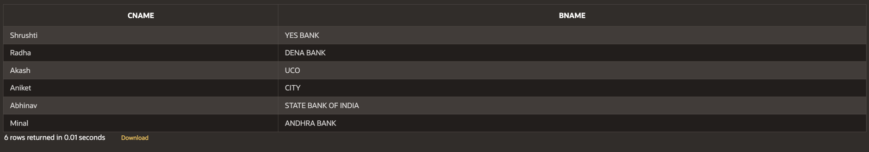

6) List all data from table BORROW.

SELECT * FROM BORROW;



(7) Give customer name and loan amount of borrowers.

SELECT CNAME, AMOUNT FROM BORROW;

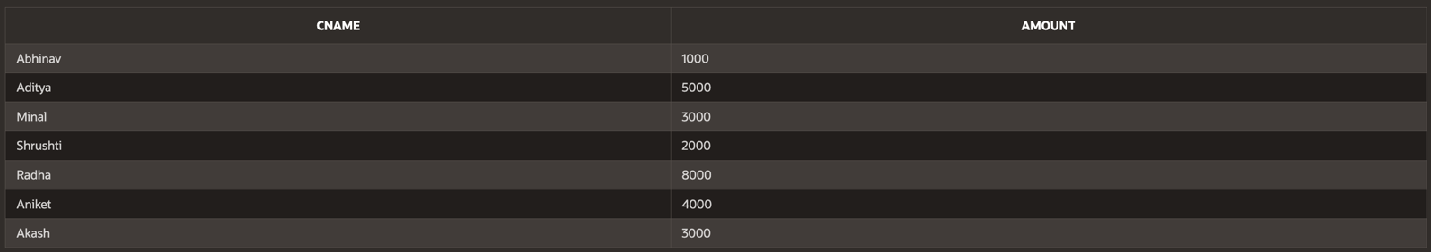

(8) Give name of borrows from YES BANK branch and loan amount greater than 3000.

SELECT CNAME, AMOUNT FROM BORROW
WHERE BNAME = 'YES BANK' AND AMOUNT > 3000;

(9) List all data from table CUSTOMERS.

SELECT * FROM CUSTOMERS;



(10) list name of customers from BOMBAY.

SELECT CNAME FROM CUSTOMERS WHERE CITY = 'BOMBAY';

(11) List all data from table BRANCH.

SELECT * FROM BRANCH;



(12) Give name of customers who opened account after date '1-12-96'.

SELECT CNAME FROM DEPOSIT WHERE ADATE > '01-DEC-96';

iv) Change the name of borrow to loan (rename borrow to loan)

ALTER TABLE BORROW RENAME TO LOAN;

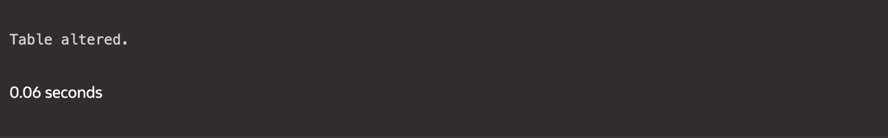

V) Give the SQL solutions for following queries

- Select branch names from the loan relation

SELECT BNAME FROM LOAN;

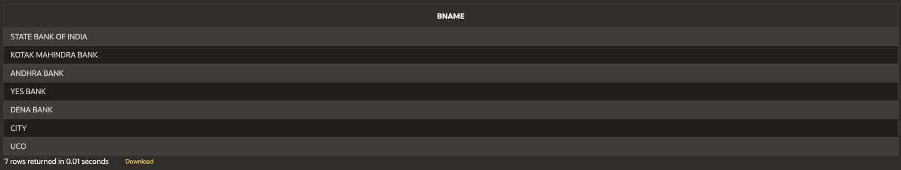

- List all the tuples & attributes from the loan relation

SELECT * FROM LOAN;

- Select branch_name & loan no. From the loan relation.

SELECT BNAME, LOANNO FROM LOAN;

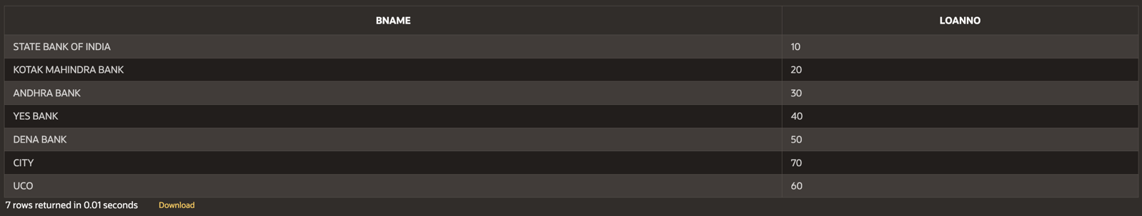

- Select all the loan numbers & amount from the loan relation.

SELECT LOANNO, AMOUNT FROM LOAN;

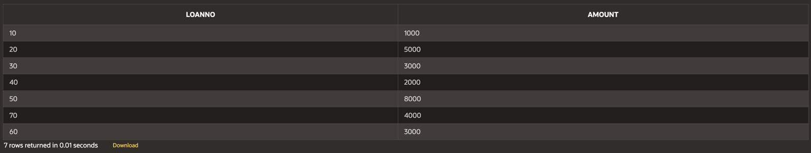

- Find all loan no. & amount of the DENA BANK branch where the amount is Greater than 1300

SELECT LOANNO, AMOUNT FROM LOAN
WHERE BNAME = 'DENA BANK' AND AMOUNT > 1300;

- Give 10% interest to all depositors.

UPDATE DEPOSIT SET AMOUNT = AMOUNT * 1.10;

- Give 10% interest to all depositors having branch UCO

UPDATE DEPOSIT SET AMOUNT = AMOUNT * 1.10 WHERE BNAME = 'UCO;

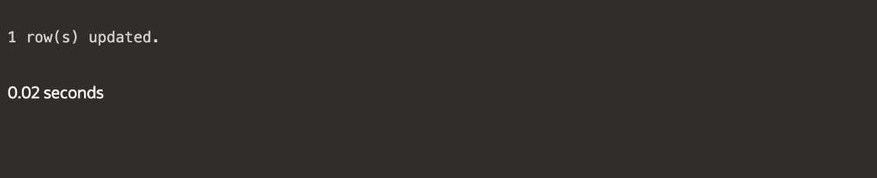

- Delete deposit of VIJAY

DELETE FROM DEPOSIT WHERE CNAME = 'VIJAY';
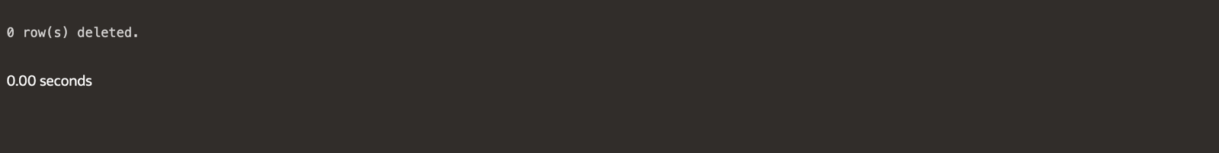

- Deletecustomers from BOMBAY city

DELETE FROM CUSTOMERS WHERE CITY = 'BOMBAY';

- Delete depositors if the branch is ANDHRA BANK and depositor name is Aditya Karansingh Kachhawah.

DELETE FROM DEPOSIT
WHERE BNAME = 'ANDHRA BANK' AND CNAME = 'ADITYA KARANSINGH KACHHAWAH';



- Delete depositors having deposit less than 500

DELETE FROM DEPOSIT WHERE AMOUNT < 500;



- Delete borrower having loan more than 10000

DELETE FROM LOAN WHERE AMOUNT > 10000;



- Delete borrower having loan more than 1000 and branch KOTAK MAHINDRA BANK

DELETE FROM LOAN
WHERE AMOUNT > 1000 AND BNAME = 'KOTAK MAHINDRA BANK';

- Delete borrower having branch name UCO

DELETE FROM LOAN WHERE BNAME = 'UCO';

